Project Design Phase–II
Data Flow Diagram & User Stories

Date | 31/10/25
Team ID | NM2025TMID03029
Project Name | Optimization User, group and role management with access control and workflow
Maximum marks | 4 Marks

Data Flow Diagrams (DFD)
A Data Flow Diagram (DFD) is a graphical representation of how data moves within a system. It shows how inputs are transformed into outputs through processes, where data is stored, and how entities interact with the system.

In the project "Optimization of User, Group and Role Management with Access Control and Workflows", the DFD explains how user-related information (user details, groups, and role permissions) flows within the system, ensuring secure and controlled access through defined workflows.
This DFD illustrates:
How admins create users, assign them to groups, and allocate roles.
How the system enforces role-based access control (RBAC) to manage permissions.
How workflow automation handles access approval and notifications.
Example:
- Admin/User logs in to the system.
- System verifies credentials and retrieves permissions from the Role Database.
- Admin performs operations such as creating or modifying users, groups, and roles.
- Workflow Engine triggers approval flows for role changes or access requests.
- Access Control Module checks role-based permissions before granting access.
- Audit Log Database records all user activities and workflow approvals.
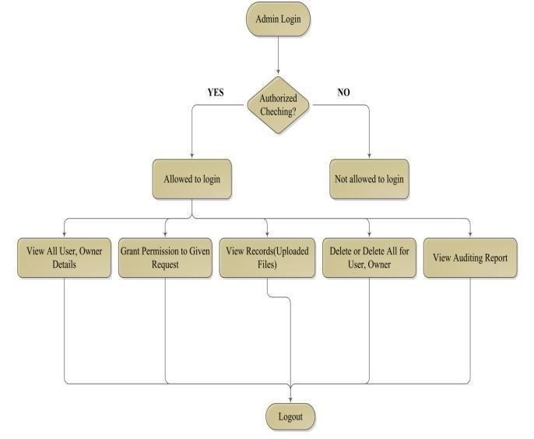

User Stories
User stories describe the system’s functionality from different user perspectives using simple, goal-oriented language. They help capture the functional requirements for user, group, and role management with workflows.

User Type | Functional  Requirement  (Epics) | User  Story  Number | User Story / Tasks | Acceptance  Criteria | Priority | Release
Administrator | User  Management | USD-1 | As an admin, I want to create, edit, and delete users  so that I can  manage system access. | The system should allow CRUD operations only for  admins with valid permissions. | High | Sprint - 1
Admin / Security officer | Role  Management | USD-2 | As an admin, I want to assign specific roles | The system should enforce RBAC and | High | Sprint 1
 |  |  | and  permissions to users or groups to maintain access security. | restrict  unauthorized changes.
Workflow Manager | Workflow  Automation | USD-3 | As a manager, I want to review and approve access requests through automated workflows. | Workflow requests must require approval before access is granted. | Medium | Sprint 2
System  (auto check) | Access validation | USD-4 | As a system, I must verify user roles and permissions before granting access to any resource. | Access should only be granted  after successful validation. | High | Sprint -  2
Auditor/  Compliance | Audit logging | USD-5 | As an auditor, I want to view logs of all user and role changes to ensure accountability. | Logs must be automatically y generated and tamperproof. | Medium | Sprint 3

